***Top 1000 Youtubers Analysis***

**1. Overall view of top 1000 youtubers dataset:**

SELECT

COUNT(DISTINCT Country) AS Total_countries,

COUNT(DISTINCT Categories) AS total_categories,

AVG(Suscribers) AS avg_suscribers,

AVG(Visits) AS avg_visits,

AVG(Likes) AS avg_likes,

AVG(Comments) AS avg_comments

FROM [Clean_Top_1000_Youtube_df - youtubers_df]

**2. Top Category:**

SELECT

Categories,

COUNT(Username) AS Total_channel

FROM [Clean_Top_1000_Youtube_df - youtubers_df]

GROUP BY Categories

ORDER BY Total_channel DESC

**3.Geographical Analysis:**

SELECT TOP 10

Country,

COUNT(Username) AS Total_channel

FROM [Clean_Top_1000_Youtube_df - youtubers_df]

GROUP BY Country

ORDER BY Total_channel DESC

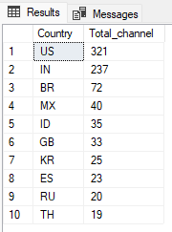

**4. Subscribers Engagement:**

SELECT TOP 10

Username,

AVG(Suscribers) AS avg_suscribers,

AVG(Visits) AS avg_visits,

AVG(Likes) AS avg_likes,

AVG(Comments) AS avg_comments

FROM [Clean_Top_1000_Youtube_df - youtubers_df]

GROUP BY Username

ORDER BY avg_suscribers

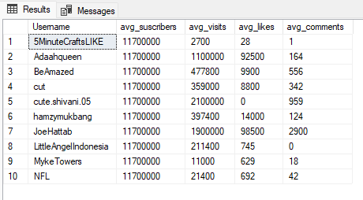

**5. Top performance identification:**

SELECT TOP 10

Username,

Suscribers,

Country

FROM [Clean_Top_1000_Youtube_df - youtubers_df]

ORDER BY Suscribers DESC

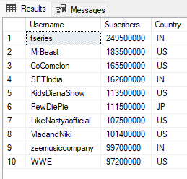

**6. Content and Channel recommendations:**

SELECT TOP 10

Categories,

AVG(Suscribers) AS avg_suscribers,

AVG(Visits) AS avg_visits,

AVG(Likes) AS avg_likes,

AVG(Comments) AS avg_comments

FROM [Clean_Top_1000_Youtube_df - youtubers_df]

GROUP BY Categories

ORDER BY avg_suscribers DESC

**7. Cross Country subscribers’ engagement:**

SELECT TOP 10

Country,

AVG(Suscribers) AS avg_suscribers,

AVG(Visits) AS avg_visits,

AVG(Likes) AS avg_likes,

AVG(Comments) AS avg_comments

FROM [Clean_Top_1000_Youtube_df - youtubers_df]

GROUP BY Country

ORDER BY avg_suscribers DESC

